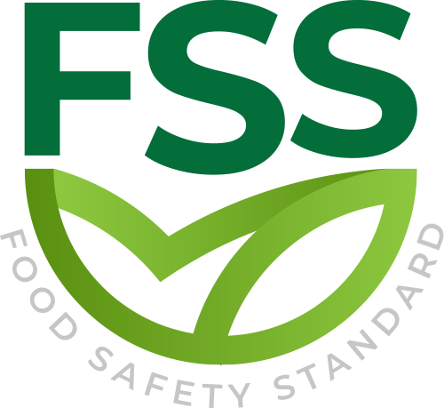

REQUIREMENTS FOR TRAINING ORGANIZATIONS

Document Code _ FSS-STD-006
Approval Date : 20.02.2020

Title: Food Safety Standard (FSS)
Contact Adress : Merkez Mahallesi Dr Sadık Ahmet Cd, No 38/44 A Bağcılar/İstanbul – Türkiye / Turkey
Contact Mail: info@foodcertificate.org
Website: www.foodcertificate.org
Phone: +90 212 702 40 00

ABOUT US
The Food Safety System (FSS) certification program developed by our organization is a system for the inspection and evaluation of food safety and quality according to accepted standards. The certification program in question not only ensures food safety, but also undertakes responsibilities such as public health and environmental protection. This certification program is recognized as the most important initiative of recent years for a more effective and quality food management.

While developing the Food Safety System (FSS) certification program, our organization followed a global food safety strategy and adopted a safer food policy to be healthier. According to this strategy, preventing foodborne diseases and ensuring food safety require holistic, risk-based and timely food safety policies and strategies.

Our organization continuously improves its effectiveness by participating in the efforts for the development and implementation of the food management system in enterprises. It supports businesses in the food industry to meet legal and regulatory requirements, tries to establish a quality policy in businesses, supports businesses in establishing food safety targets, directs management reviews and tries to ensure the correct and effective availability of resources. In all these works, our organization approaches businesses in an impartial and independent manner and does not enter into any conflict of interest.

Our organization acts with a sense of responsibility in order to be with people who care about their nutrition and to help them make safe food choices. In this context, it provides Food Safety System (FSS) certification services to support companies that produce, store, distribute and prepare food in order to prove their efforts in this direction.

- SCOPE
This section specifies the requirements for licensed training institutions that wish to
provide approved FSS training courses.
- LICENSE
FSS training services can only be provided if they hold a valid (complete) license for the relevant training scope issued by the foundation.
B.1 Application
Training institutions should submit an application to the foundation stating the type of training they wish to apply for. The application form is available on the FSS website. The required information includes:
a) Contact information;
b) TO operation;
c) Regional activities;
d) Types of FSS courses offered;
e) FSS trainer.
The application form details which documents need to be provided at each stage of the process.

B.2 LICENSE AGREEMENT
- After successfully reviewing the application and paying the required fees to the foundation, the applicant will obtain a license agreement with a provisional status.
- The signed license agreement (temporarily) allows training institutions to access FSS training materials, which can be used as a basis for developing their own training materials. The Traning Organization shall not offer or market any FSS courses approved by the foundation until the full license agreement is obtained.
- The license agreement (temporary) is valid for 12 months from the date of signing by the foundation. During this period, the Training Organization shall follow the steps in the next section to upgrade the status of its license agreement to a complete state.
C. RESPONSIBILITIES AND COMMUNICATION
- At least one Traning Organization representative should attend the annual coordination meeting and FSS technical webinar;
- Information obtained through coordination meetings and technical webinars should be shared and coordinated within Traning Organization;
- The training plan should be shared with the foundation every year to update it on the FSS website;
- The use of the FSS logo should meet the requirements of the scheme;
- Comply with all relevant program requirements;
- Participate in the foundation's integrity plan;
- Timely payment of fees to the foundation;
- Traning Organization shall designate a contact person and a reserve person to communicate with the foundation;

D. TRAINING
- Courses for organizations, CBs, consultants, and others who are interested in general knowledge of the program requirements and understand how it applies to others in different food chain organizations. The duration is usually 2-4 days, depending on the target audience and learning goals.
- Courses for organizations, consultants, and others, based on above, show how to implement the plan in various food chain categories. The duration is usually 2-4 days, depending on the target audience and learning goals.
- Designed for organizations that implement FSS to meet internal auditor training requirements. The duration is usually 1-2 days, depending on the target audience and learning goals. The training should cover all the elements specified in ISO 19011:2018.
- Designed specifically for CB personnel/employees to become qualified lead auditors. It may also be suitable for organizations and consultants who wish to further develop their internal audit skills. The minimum duration of the course is 40 hours. Prerequisite knowledge of FSS is required. The training should cover all the elements specified in ISO 19011:2018, ISO/IEC 17021-1:2015 and ISO/TS 22003:2013, and should include exercises and written examinations. If the representative does not take the exam, it will be regarded as a "failed exam" and only an attendance certificate can be issued.

E. OPERATIONAL PROCESSES
- Before each training, Training Organization should determine the target audience and accompanying learning goals.
- Traning Organization shall specify the prerequisites of the course and specify the minimum education/experience level represented by its course.
- The design of all courses shall include the following elements: content;purpose;target audience;course prerequisites;learning objectives;training plan/course agenda;tutor notes;delegate notes;handouts (as required);assessment methodology;training resources.
- The training materials shall provide a clear explanation of the FSS Scheme requirements: ISO 22000 (FSMS, hazard control); Additional Scheme specific requirements.
F. LEARNING ENVIRONMENT AND RESOURCES
- Training Organization shall ensure:
a) All resources defined in the course are available;
b) All trainers responsible for providing training have these resources and received training in their use;
c) Course representatives can access all resources defined in the course.
- Training Organization shall ensure that necessary staff, staff and learning resources are selected and deployed in consideration of any specific needs, and the learning resources are maintained.

G. EFFECTIVENESS OF TRAINING
1) Training Organization shall track the success rate of course representatives who have completed the training (the number of course representatives who have passed and failed the course).
2) The Training Organization shall assess whether the course representative is satisfied with the training (and examination, if applicable).
3) After each training, Training Organization shall conduct a customer satisfaction survey. Training Organization shall take any necessary actions to make improvements in accordance with its continuous improvement plan. Investigation records should be kept.
H. FSS TRAINING CERTIFICATES
- Training Organization shall issue the following certificates to all participants:
a) Proof of attendance, in which there is no test or the participant failed the test.
b) Proof of results, passing examinations and evaluations.
I. DOCUMENT CONTROL
TO should have a system to ensure that only the latest version of the project document is used, and changes to the project should be implemented in accordance with the requirements of the foundation. TO shall review and update the training materials before the delivery of the next training course after each plan update is released.
J. COMPLAINTS AND APPEALS
All complaints from course representatives, trainers or other related parties should be registered.Investigate the complaint and take corrective measures to solve the problem. Records should be kept.Training Organization has the right to appeal any decision made through the sanctions policy. The details are in

